A000-Afr-Nigeria-Yoruba-Male Offertory Statue-mid 20th c

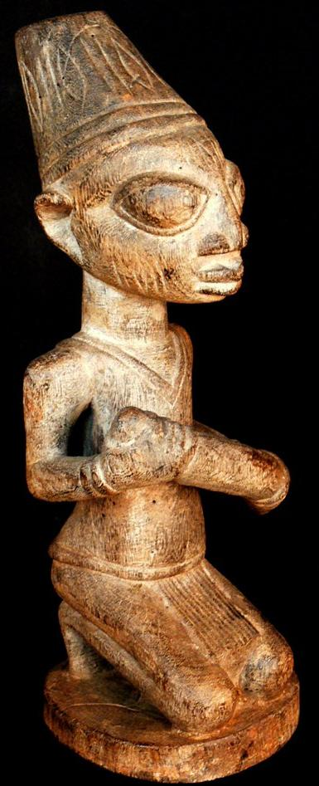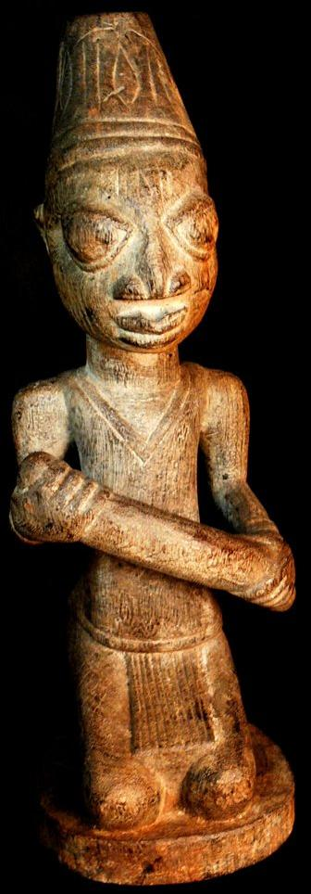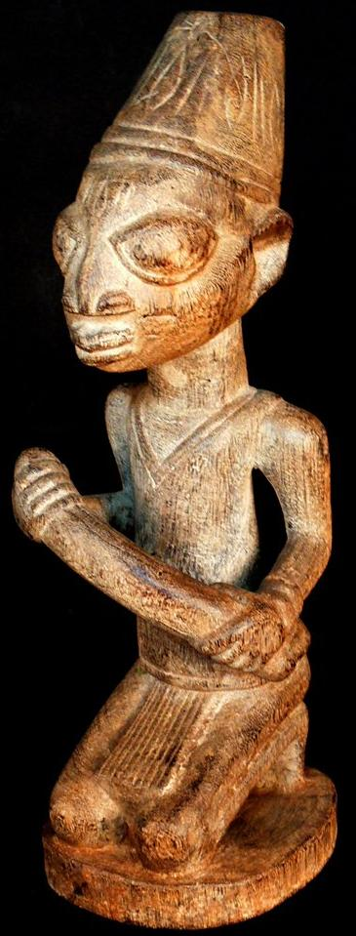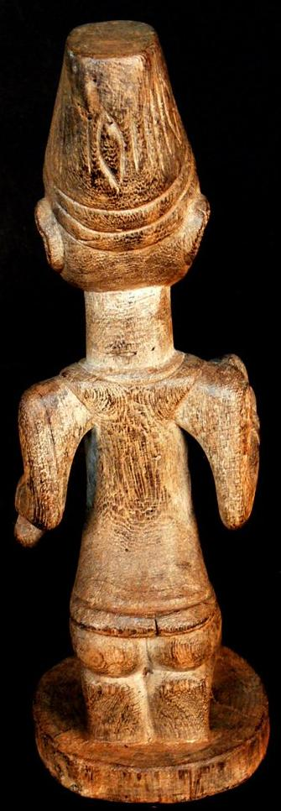

Figs 1-4. Afr-Nigeria-Yoruba-Male Offertory Statue-mid 20th c

Case No.: 6

**Accession No.**

**Formal Label:** Afr-Nigeria-Yoruba-Male Offertory Statue-mid 20th c

**Display Description:**

In [Yoruban](http://www.library.illinois.edu/contentdm/cdm4/results.php?CISOOP1=any&CISOFIELD1=CISOSEARCHALL&CISOROOT=/tdc&CISOBOX1=Yoruban) [society](http://www.library.illinois.edu/contentdm/cdm4/results.php?CISOOP1=any&CISOFIELD1=CISOSEARCHALL&CISOROOT=/tdc&CISOBOX1=society), [various](http://www.library.illinois.edu/contentdm/cdm4/results.php?CISOOP1=any&CISOFIELD1=CISOSEARCHALL&CISOROOT=/tdc&CISOBOX1=Various) [realistically](http://www.library.illinois.edu/contentdm/cdm4/results.php?CISOOP1=any&CISOFIELD1=CISOSEARCHALL&CISOROOT=/tdc&CISOBOX1=realistically) [carved](http://www.library.illinois.edu/contentdm/cdm4/results.php?CISOOP1=any&CISOFIELD1=CISOSEARCHALL&CISOROOT=/tdc&CISOBOX1=carved) [figures](http://www.library.illinois.edu/contentdm/cdm4/results.php?CISOOP1=any&CISOFIELD1=CISOSEARCHALL&CISOROOT=/tdc&CISOBOX1=figures) were used for [presenting](http://www.library.illinois.edu/contentdm/cdm4/results.php?CISOOP1=any&CISOFIELD1=CISOSEARCHALL&CISOROOT=/tdc&CISOBOX1=presenting) [gifts](http://www.library.illinois.edu/contentdm/cdm4/results.php?CISOOP1=any&CISOFIELD1=CISOSEARCHALL&CISOROOT=/tdc&CISOBOX1=gifts) of [food](http://www.library.illinois.edu/contentdm/cdm4/results.php?CISOOP1=any&CISOFIELD1=CISOSEARCHALL&CISOROOT=/tdc&CISOBOX1=food) to [important](http://www.library.illinois.edu/contentdm/cdm4/results.php?CISOOP1=any&CISOFIELD1=CISOSEARCHALL&CISOROOT=/tdc&CISOBOX1=important) [visitors](http://www.library.illinois.edu/contentdm/cdm4/results.php?CISOOP1=any&CISOFIELD1=CISOSEARCHALL&CISOROOT=/tdc&CISOBOX1=visitors), and as [part](http://www.library.illinois.edu/contentdm/cdm4/results.php?CISOOP1=any&CISOFIELD1=CISOSEARCHALL&CISOROOT=/tdc&CISOBOX1=part) of [rituals.](http://www.library.illinois.edu/contentdm/cdm4/results.php?CISOOP1=any&CISOFIELD1=CISOSEARCHALL&CISOROOT=/tdc&CISOBOX1=rituals.) [Kneeling](http://www.library.illinois.edu/contentdm/cdm4/results.php?CISOOP1=any&CISOFIELD1=CISOSEARCHALL&CISOROOT=/tdc&CISOBOX1=Kneeling) [suggests](http://www.library.illinois.edu/contentdm/cdm4/results.php?CISOOP1=any&CISOFIELD1=CISOSEARCHALL&CISOROOT=/tdc&CISOBOX1=suggests) a [relationship](http://www.library.illinois.edu/contentdm/cdm4/results.php?CISOOP1=any&CISOFIELD1=CISOSEARCHALL&CISOROOT=/tdc&CISOBOX1=relationship) to a [higher](http://www.library.illinois.edu/contentdm/cdm4/results.php?CISOOP1=any&CISOFIELD1=CISOSEARCHALL&CISOROOT=/tdc&CISOBOX1=higher) [force](http://www.library.illinois.edu/contentdm/cdm4/results.php?CISOOP1=any&CISOFIELD1=CISOSEARCHALL&CISOROOT=/tdc&CISOBOX1=force) and [is](http://www.library.illinois.edu/contentdm/cdm4/results.php?CISOOP1=any&CISOFIELD1=CISOSEARCHALL&CISOROOT=/tdc&CISOBOX1=is) a [pose](http://www.library.illinois.edu/contentdm/cdm4/results.php?CISOOP1=any&CISOFIELD1=CISOSEARCHALL&CISOROOT=/tdc&CISOBOX1=pose) of [respect](http://www.library.illinois.edu/contentdm/cdm4/results.php?CISOOP1=any&CISOFIELD1=CISOSEARCHALL&CISOROOT=/tdc&CISOBOX1=respect), [whether](http://www.library.illinois.edu/contentdm/cdm4/results.php?CISOOP1=any&CISOFIELD1=CISOSEARCHALL&CISOROOT=/tdc&CISOBOX1=whether) [it](http://www.library.illinois.edu/contentdm/cdm4/results.php?CISOOP1=any&CISOFIELD1=CISOSEARCHALL&CISOROOT=/tdc&CISOBOX1=it) [is](http://www.library.illinois.edu/contentdm/cdm4/results.php?CISOOP1=any&CISOFIELD1=CISOSEARCHALL&CISOROOT=/tdc&CISOBOX1=is) a [subject](http://www.library.illinois.edu/contentdm/cdm4/results.php?CISOOP1=any&CISOFIELD1=CISOSEARCHALL&CISOROOT=/tdc&CISOBOX1=subject) [kneeling](http://www.library.illinois.edu/contentdm/cdm4/results.php?CISOOP1=any&CISOFIELD1=CISOSEARCHALL&CISOROOT=/tdc&CISOBOX1=kneeling) [before](http://www.library.illinois.edu/contentdm/cdm4/results.php?CISOOP1=any&CISOFIELD1=CISOSEARCHALL&CISOROOT=/tdc&CISOBOX1=before) his [king](http://www.library.illinois.edu/contentdm/cdm4/results.php?CISOOP1=any&CISOFIELD1=CISOSEARCHALL&CISOROOT=/tdc&CISOBOX1=king), a [young](http://www.library.illinois.edu/contentdm/cdm4/results.php?CISOOP1=any&CISOFIELD1=CISOSEARCHALL&CISOROOT=/tdc&CISOBOX1=young) [bride](http://www.library.illinois.edu/contentdm/cdm4/results.php?CISOOP1=any&CISOFIELD1=CISOSEARCHALL&CISOROOT=/tdc&CISOBOX1=bride) [before](http://www.library.illinois.edu/contentdm/cdm4/results.php?CISOOP1=any&CISOFIELD1=CISOSEARCHALL&CISOROOT=/tdc&CISOBOX1=before) her [husband](http://www.library.illinois.edu/contentdm/cdm4/results.php?CISOOP1=any&CISOFIELD1=CISOSEARCHALL&CISOROOT=/tdc&CISOBOX1=husband), or a [child](http://www.library.illinois.edu/contentdm/cdm4/results.php?CISOOP1=any&CISOFIELD1=CISOSEARCHALL&CISOROOT=/tdc&CISOBOX1=child) for a [parent.](http://www.library.illinois.edu/contentdm/cdm4/results.php?CISOOP1=any&CISOFIELD1=CISOSEARCHALL&CISOROOT=/tdc&CISOBOX1=parent.) Here a [man](http://www.library.illinois.edu/contentdm/cdm4/results.php?CISOOP1=any&CISOFIELD1=CISOSEARCHALL&CISOROOT=/tdc&CISOBOX1=woman) [offers](http://www.library.illinois.edu/contentdm/cdm4/results.php?CISOOP1=any&CISOFIELD1=CISOSEARCHALL&CISOROOT=/tdc&CISOBOX1=offers) a [sugar](http://www.library.illinois.edu/contentdm/cdm4/results.php?CISOOP1=any&CISOFIELD1=CISOSEARCHALL&CISOROOT=/tdc&CISOBOX1=fowl) cane, a [traditional](http://www.library.illinois.edu/contentdm/cdm4/results.php?CISOOP1=any&CISOFIELD1=CISOSEARCHALL&CISOROOT=/tdc&CISOBOX1=traditional) [Yoruban](http://www.library.illinois.edu/contentdm/cdm4/results.php?CISOOP1=any&CISOFIELD1=CISOSEARCHALL&CISOROOT=/tdc&CISOBOX1=Yoruban) [motif](http://www.library.illinois.edu/contentdm/cdm4/results.php?CISOOP1=any&CISOFIELD1=CISOSEARCHALL&CISOROOT=/tdc&CISOBOX1=motif) which is [typically](http://www.library.illinois.edu/contentdm/cdm4/results.php?CISOOP1=any&CISOFIELD1=CISOSEARCHALL&CISOROOT=/tdc&CISOBOX1=typically) [sacrificed](http://www.library.illinois.edu/contentdm/cdm4/results.php?CISOOP1=any&CISOFIELD1=CISOSEARCHALL&CISOROOT=/tdc&CISOBOX1=sacrificed) in [Yoruban](http://www.library.illinois.edu/contentdm/cdm4/results.php?CISOOP1=any&CISOFIELD1=CISOSEARCHALL&CISOROOT=/tdc&CISOBOX1=Yoruban) [rituals.](http://www.library.illinois.edu/contentdm/cdm4/results.php?CISOOP1=any&CISOFIELD1=CISOSEARCHALL&CISOROOT=/tdc&CISOBOX1=rituals;) [Images](http://www.library.illinois.edu/contentdm/cdm4/results.php?CISOOP1=any&CISOFIELD1=CISOSEARCHALL&CISOROOT=/tdc&CISOBOX1=Images) in [African](http://www.library.illinois.edu/contentdm/cdm4/results.php?CISOOP1=any&CISOFIELD1=CISOSEARCHALL&CISOROOT=/tdc&CISOBOX1=African) [art](http://www.library.illinois.edu/contentdm/cdm4/results.php?CISOOP1=any&CISOFIELD1=CISOSEARCHALL&CISOROOT=/tdc&CISOBOX1=art) [rarely](http://www.library.illinois.edu/contentdm/cdm4/results.php?CISOOP1=any&CISOFIELD1=CISOSEARCHALL&CISOROOT=/tdc&CISOBOX1=rarely) [depict](http://www.library.illinois.edu/contentdm/cdm4/results.php?CISOOP1=any&CISOFIELD1=CISOSEARCHALL&CISOROOT=/tdc&CISOBOX1=depict) [specific](http://www.library.illinois.edu/contentdm/cdm4/results.php?CISOOP1=any&CISOFIELD1=CISOSEARCHALL&CISOROOT=/tdc&CISOBOX1=specific) [people](http://www.library.illinois.edu/contentdm/cdm4/results.php?CISOOP1=any&CISOFIELD1=CISOSEARCHALL&CISOROOT=/tdc&CISOBOX1=people), but [instead](http://www.library.illinois.edu/contentdm/cdm4/results.php?CISOOP1=any&CISOFIELD1=CISOSEARCHALL&CISOROOT=/tdc&CISOBOX1=instead) are [generic](http://www.library.illinois.edu/contentdm/cdm4/results.php?CISOOP1=any&CISOFIELD1=CISOSEARCHALL&CISOROOT=/tdc&CISOBOX1=generic) [symbols](http://www.library.illinois.edu/contentdm/cdm4/results.php?CISOOP1=any&CISOFIELD1=CISOSEARCHALL&CISOROOT=/tdc&CISOBOX1=symbols) of the [lineage](http://www.library.illinois.edu/contentdm/cdm4/results.php?CISOOP1=any&CISOFIELD1=CISOSEARCHALL&CISOROOT=/tdc&CISOBOX1=lineage), [progeny](http://www.library.illinois.edu/contentdm/cdm4/results.php?CISOOP1=any&CISOFIELD1=CISOSEARCHALL&CISOROOT=/tdc&CISOBOX1=progeny) and [clan](http://www.library.illinois.edu/contentdm/cdm4/results.php?CISOOP1=any&CISOFIELD1=CISOSEARCHALL&CISOROOT=/tdc&CISOBOX1=clan) [forebears.](http://www.library.illinois.edu/contentdm/cdm4/results.php?CISOOP1=any&CISOFIELD1=CISOSEARCHALL&CISOROOT=/tdc&CISOBOX1=forebears.)

**LC Classification:**

**Date or Time Horizon:**

**Geographical Area:**

**Map:**

**GPS coordinates:**

**Cultural Affiliation:**

**Media:**

**Dimensions:** 13.37 inches

**Weight:** 1.97 pounds

**Condition:**

**Provenance:**

**Discussion:**

**References:**